

**CSE 222**

**PROJECT PROPOSAL - GROUP 1**

**Prison Management System**

**1. Group Members**

**1.**

**2.**

**3.**

**4.**

**5.**

**6.**

**7.**

**8.**

**AHMET BEDİR ACAR FEYZA NUR AKYOL ALPER YAŞAR**

**DJURO RADUSINOVIC AKİF KARTAL**

**MERT CAN BEŞİRLİ MEHDİ KURTCEBE**

**MİRAY YILDIZ**

141044074

161044005

151044072

171044095

171044098

1801042663

1801042667

161044023



**2. Problem Deﬁnition**

The problem is to manage a prison fast, easily and safely. In big institutions such as

prisons most of the time the problem is weak communication and information

among the personnel. Our aim is to solve this communication and information

problem. Prisons have personnel such as administrator, governor, chief jailer,

jailers, staff members (e.g. cook, cleaning, healthcare), prisoners etc.; or rooms

such as cells, wards, dining hall etc.

All this information is kept tracked by the system and only authorized personnel can

use this system. We call them users. Users can reach any data and do actions about

their authorities in the prison. For example; registering, head counting, shifting,

adding daily food menus etc. As a Result by using this system, we will be

able to handle weak communication and information problem such

that users can access everything immediately.



**3. Users of the System**

The prison system has users such as administrator, governor, jailers, chief jailer and

staff members(cooks , healthcare personnels and cleaning personnels).

Administrator manage the system by adding and removing governor.

Governor can enter and remove information about the prisoners such as name, surname, T.C number, criminal record, the number of the ward and prisoner’s relative information. Also, governor can add and remove another users.

He/She keeps the information of these users. This information is name,

surname, T.C number and user’s profession.

Chief jailer manages other guards. He/She assigns them to the necessary departments.

Chief jailer also manages visitor entrance and exit.

Jailers enter the census details of the prisoners every morning and evening. He/She

can access prisoners' information.

Healthcare personnels enter prisoners’ health information into the system. Arranges

the appointment system for health check.

Cleaning personnels arranges the hours of cleaning. He/She enters the cleaning

information of the wards into the system.

Cooks organize the menu and enter the menu into the system.



1. **Requirements**
   1. **Functional System Requirements**

**1.** Administrator (e.g. Secretary of Justice) shall be able to add or remove

Governor or Chief Jailer.

**2.** Governer shall be able to add or remove prisoners.

**3.** Governer shall be able to add or remove personnel

(Jailers, Cooks, Health Personnels).

**4.** Chief Jailer shall be able to manage visitors.

**5.** Chief Jailer shall be able to manage jailers (Work Deportments, Shift Hours).

**6.** Jailers shall be able to update prisoner census data.

**7.** Jailers shall be able to declare state of alert.

**8.** Healthcare Personnels shall be able to manage and update prisoners

health status.

**9.** Cooks shall be able to update daily menu.



**4. Requirements**

**4.2 Non-Functional System Requirements**

1. Hardware should be able to run at least Java SE13.
2. System can operate on any hardware. The seller is not in charge of any leaks in security if customer decides to change their hardware or their operating system.
3. System should be able to provide information on user’s request in less than 1 second in optimal conditions.
4. Anyone outside the prison ( such as visitor ) does not have any access to prisoners’ information. Visitors need to be conﬁrmed by prison’s prisoner’s to be able to enter the jail.
5. Personnel having access to the system (especially administrators) should do the training course provided by our experienced staff.
6. System should be easy to use and user experience should be simple enough so that even the elderly personnel is able to catch up fast.
7. Customer buying the system is required to report the maximum capacity of the prison (maximum number of prisoners, staff, administrators of the

system etc.)

1. For registering someone new into the system they are required to be in possession of an either id card, residential permit or a passport, otherwise they become a temporary prisoner until their identiﬁcation is conﬁrmed.
2. Reinstalling the system should be done by professionals in case of failure.

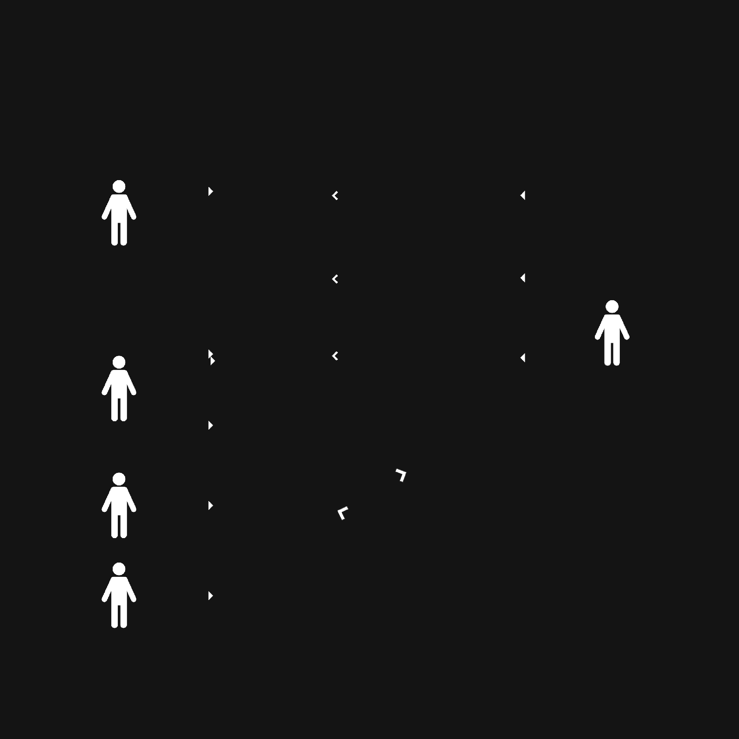

**5****. Use Case Diagram**

**PRISON**

**Add and remove Personnel**

**Personnel**

**Governor**

**Add and remove Prisoner**

**Prisoner**

**Add and remove Jailer**

**Jailer**

**Administrator**

**Visitors**

**Chief Jailer**

**Census details of Prisoners**

<<include>>

**Control of Prisoners**

**Alarm when Prisoner escapes**

<<extend>>

**Jailer**

**Cooks Healthcare Cleaning**

**Staff Member**

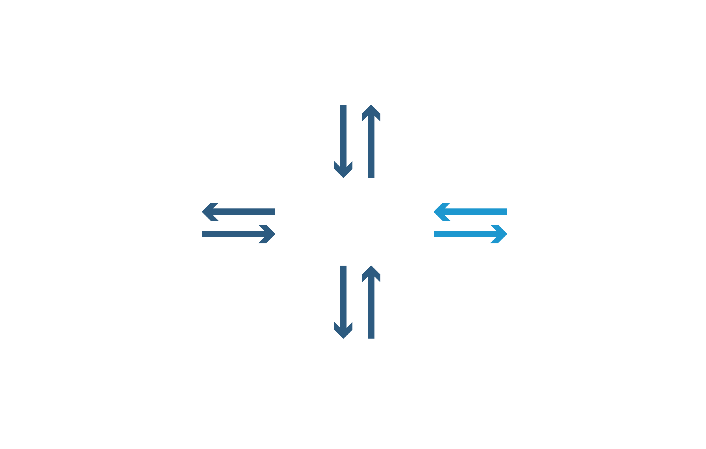

**6. Module Diagram**

**Administration**

Arrest Validation

Add to

Block

**Prison Data Processing**

**Prison Data**

**Jailer**

Remove

Verify

from

Block

Remove Prison

Add Prison

**Arrest**